1. **Login**

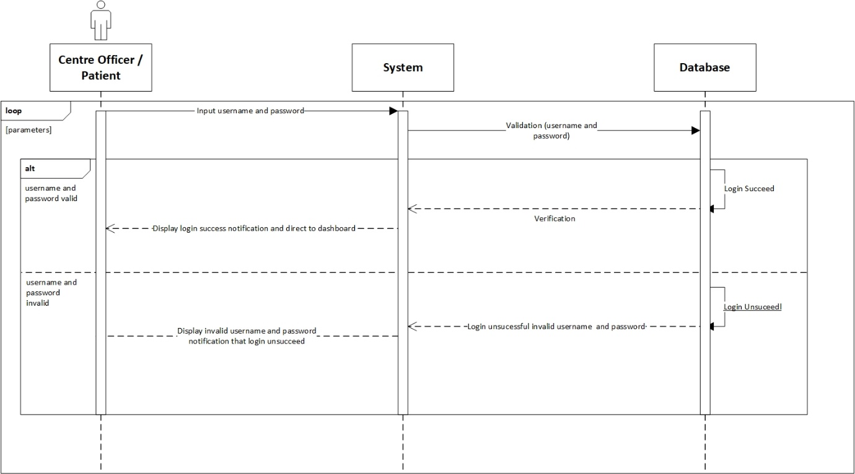

**Prepared by: Ida Bagus Gede Awidya Andika**

|  |  |
| --- | --- |
| **Cross References** | **Login** |
| Operation | Login with username and password. |
| Responsible | To access the main menu page. |
| Pre-conditions | * A valid username is required * A valid password is required |
| Post-conditions | * Username is matched * Password is matched * Display dashboard |

1. **View Test Kit**

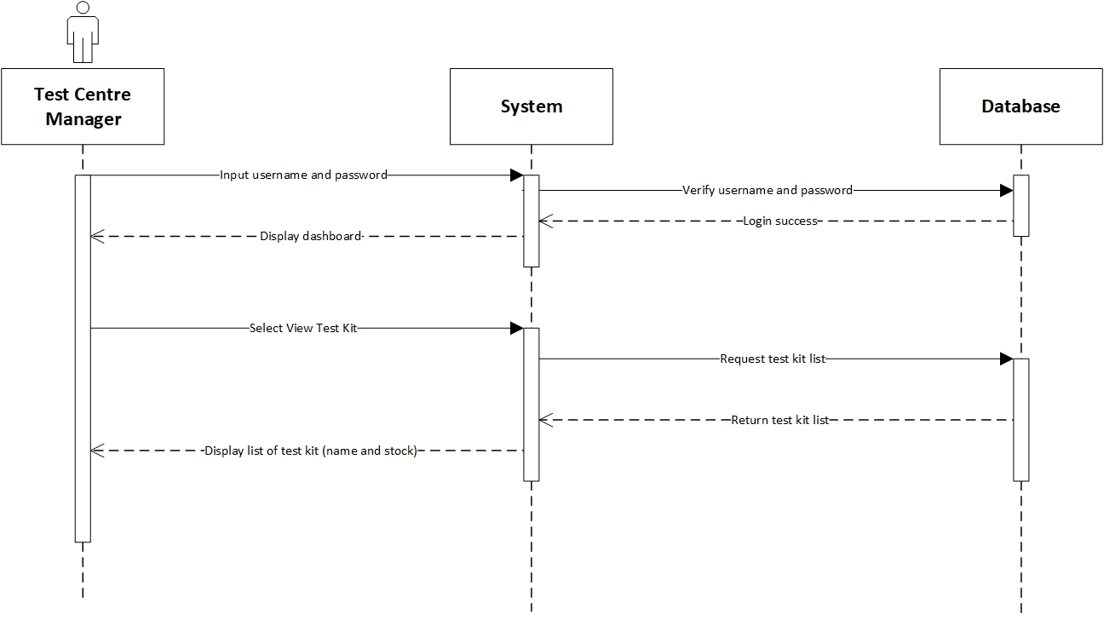

**Prepared by: Ida Bagus Gede Awidya Andika**

|  |  |
| --- | --- |
| **Cross References** | **View Test Kit** |
| Operation | Login with username and password. |
| Responsible | To access the view test kit menu. |
| Pre-conditions | * A valid username is required * A valid password is required |
| Post-conditions | * Username is matched * Password is matched * Display dashboard |
| **Cross References** | **View Test Kit** |
| Operation | View data test kit from test kit menu. |
| Responsible | To view all list data test kit. |
| Pre-conditions | The test kit object must be available. |
| Post-conditions | The list of test kit will be display name and available stock from test kit. |

1. **Manage Test Kit**

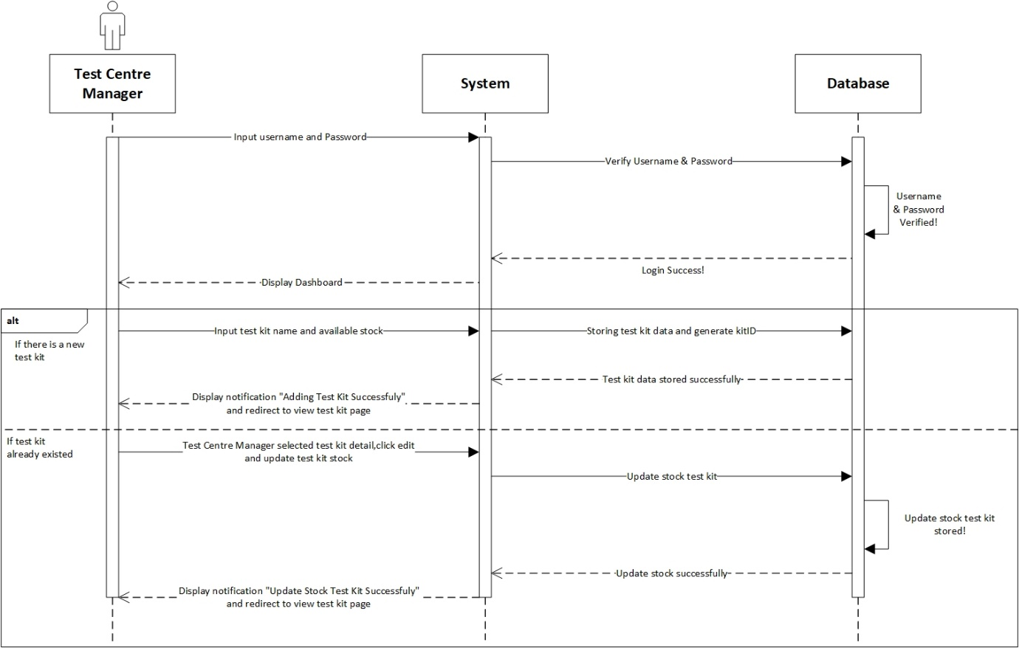

**Prepared by: Ida Bagus Gede Awidya Andika**

|  |  |
| --- | --- |
| **Cross References** | **Manage Test Kit** |
| Operation | Login with username and password. |
| Responsible | To access the manage test kit menu. |
| Pre-conditions | * A valid username is required * A valid password is required |
| Post-conditions | * Username is matched * Password is matched * Display dashboard |
| **Cross References** | **Manage Test Kit** |
| Operation | Manage test kit. |
| Responsible | To add new test kit with name and available stock. |
| Pre-conditions | Object testName and availableStock must be available. |
| Post-conditions | New test kit was successfully added to the system. |
| **Cross References** | **Manage Test Kit** |
| Operation | Manage test kit. |
| Responsible | To update available stock from test kit. |
| Pre-conditions | Detail availableStock must be available. |
| Post-conditions | Update stock test kit was successfully. |

1. **View Test Centre**

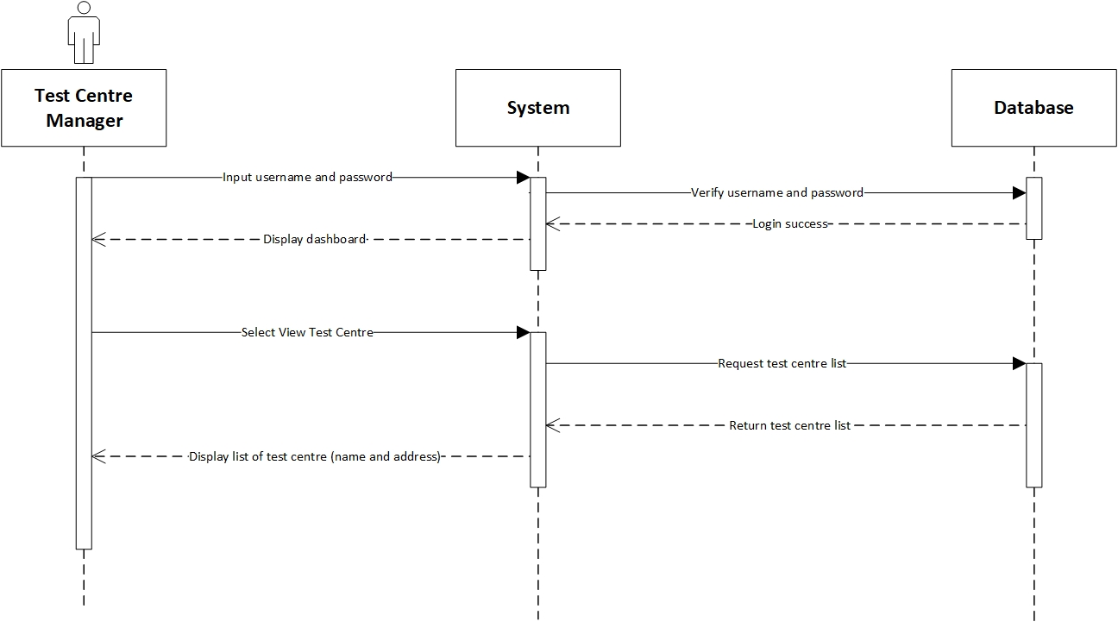

**Prepared by: Ida Bagus Gede Awidya Andika**

|  |  |
| --- | --- |
| **Cross References** | **View Test Centre** |
| Operation | Login with username and password. |
| Responsible | To access the view test centre menu. |
| Pre-conditions | * A valid username is required * A valid password is required |
| Post-conditions | * Username is matched * Password is matched * Display dashboard |
| **Cross References** | **View Test Centre** |
| Operation | View data test centre from test centre menu. |
| Responsible | To view all list data test centre. |
| Pre-conditions | The test centre object must be available. |
| Post-conditions | The list of test centre will be display name, address, postal code, phone and city from test centre. |

1. **Register Test Centre**

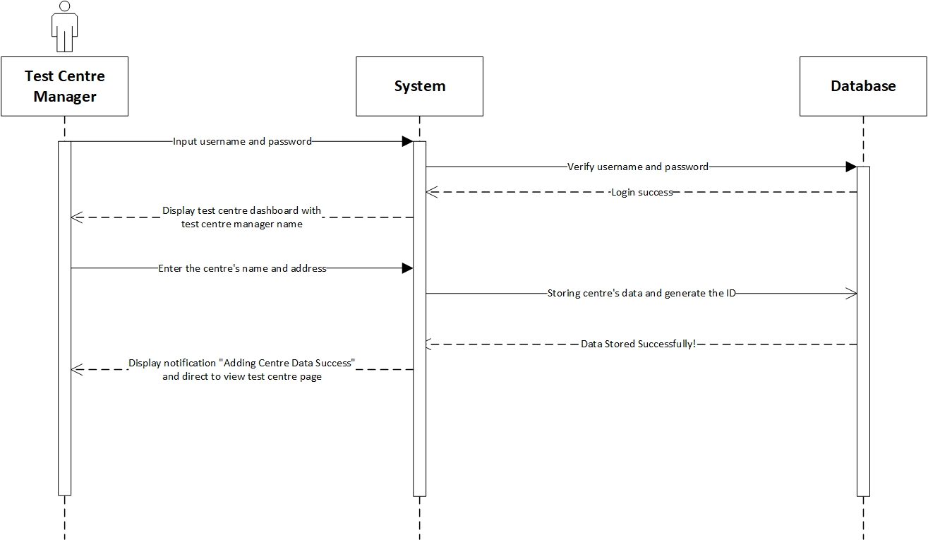

**Prepared by: Ida Bagus Gede Awidya Andika**

|  |  |
| --- | --- |
| **Cross References** | **Register Test Centre** |
| Operation | Login with username and password. |
| Responsible | To access the register test centre menu. |
| Pre-conditions | * A valid username is required * A valid password is required |
| Post-conditions | * Username is matched * Password is matched * Display dashboard |
| **Cross References** | **Register Test Centre** |
| Operation | Register test centre with name, address, postal code, phone and city from test centre. |
| Responsible | To register new test centre able to access the system. |
| Pre-conditions | Following data below that should be available:   * Name test centre * Address * Postal code * Phone * City |
| Post-conditions | Register test centre was successfully added to the system and will be display to test centre dashboard. |

1. **View Test Centre Officer**

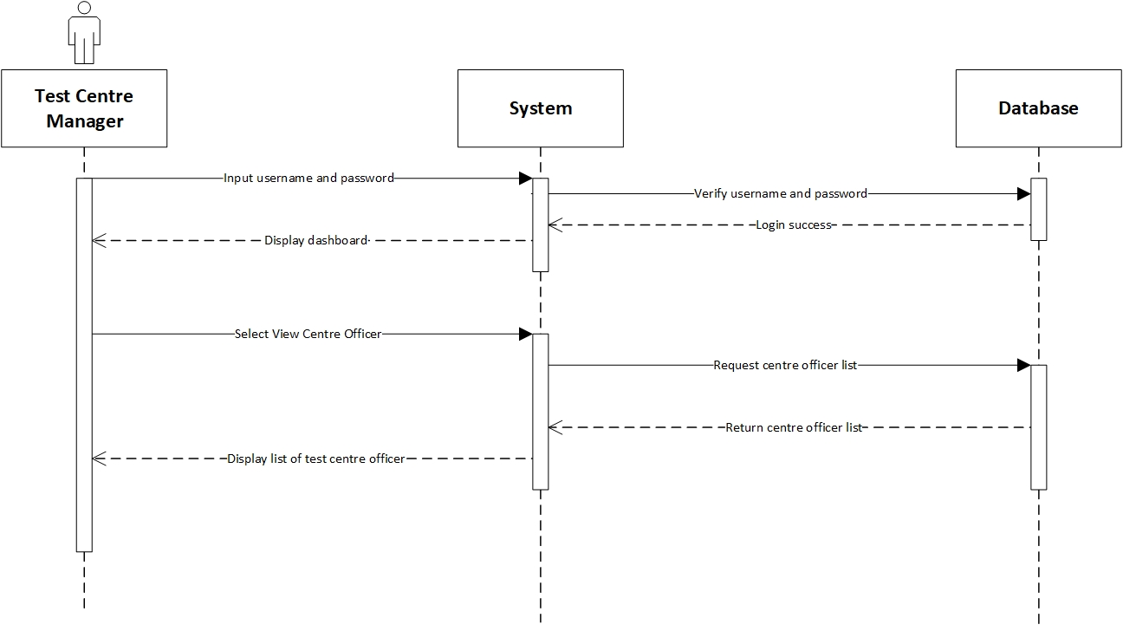

**Prepared by: Ida Bagus Gede Awidya Andika**

|  |  |
| --- | --- |
| **Cross References** | **View Test Centre Officer** |
| Operation | Login with username and password. |
| Responsible | To access the view test centre officer menu. |
| Pre-conditions | * A valid username is required * A valid password is required |
| Post-conditions | * Username is matched * Password is matched * Display dashboard |
| **Cross References** | **View Test Centre Officer** |
| Operation | View data test centre officer from test centre officer menu. |
| Responsible | To view all list data test centre. |
| Pre-conditions | The test centre officer object must be available. |
| Post-conditions | The list of test centre officer will be display name, email, phone, gender, address, age, birth date and position from test centre. |

1. **Record Tester**

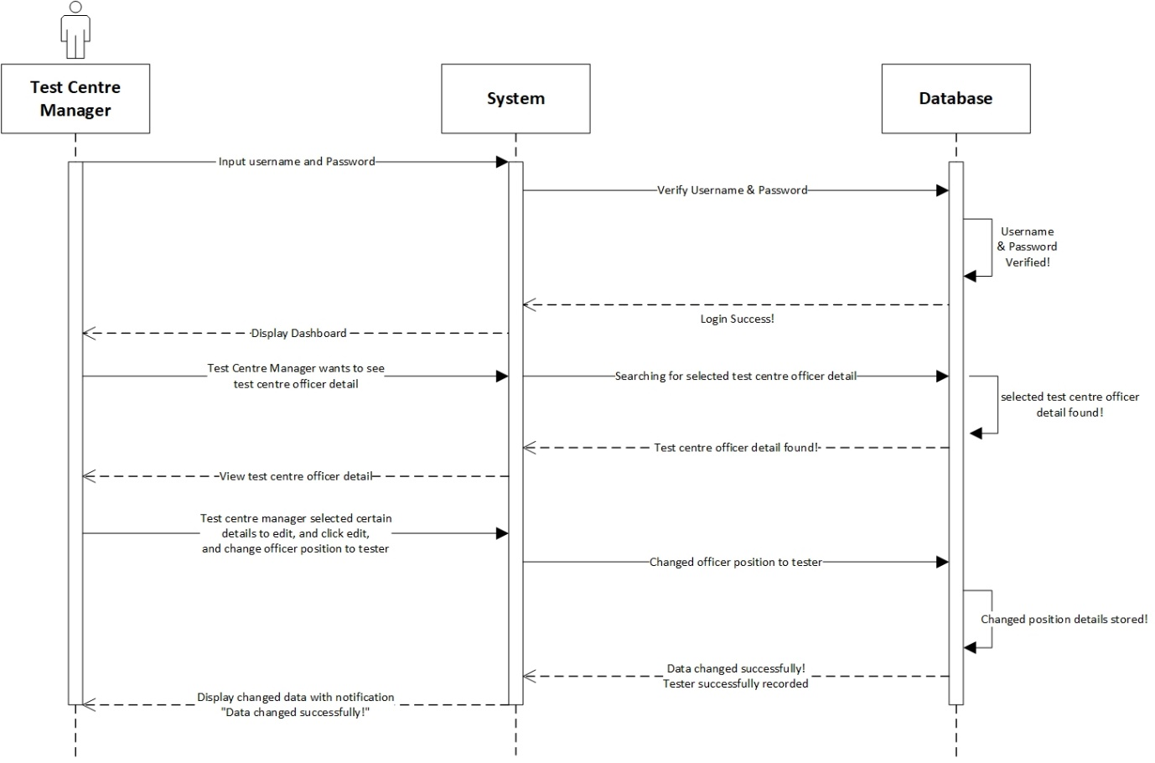

**Prepared by: I Made Siva Aditya Surya**

|  |  |
| --- | --- |
| **Cross References** | **Record Tester** |
| Operation | Login with username and password. |
| Responsible | To access the record tester menu. |
| Pre-conditions | * A valid username is required * A valid password is required |
| Post-conditions | * Username is matched * Password is matched * Display dashboard |
| **Cross References** | **Record Tester** |
| Operation | Update position test centre officer. |
| Responsible | To update the position test centre officer to tester. |
| Pre-conditions | The test centre officer must be available. |
| Post-conditions | Update position tester was successfully changed to the system. |

1. **Record Officer**

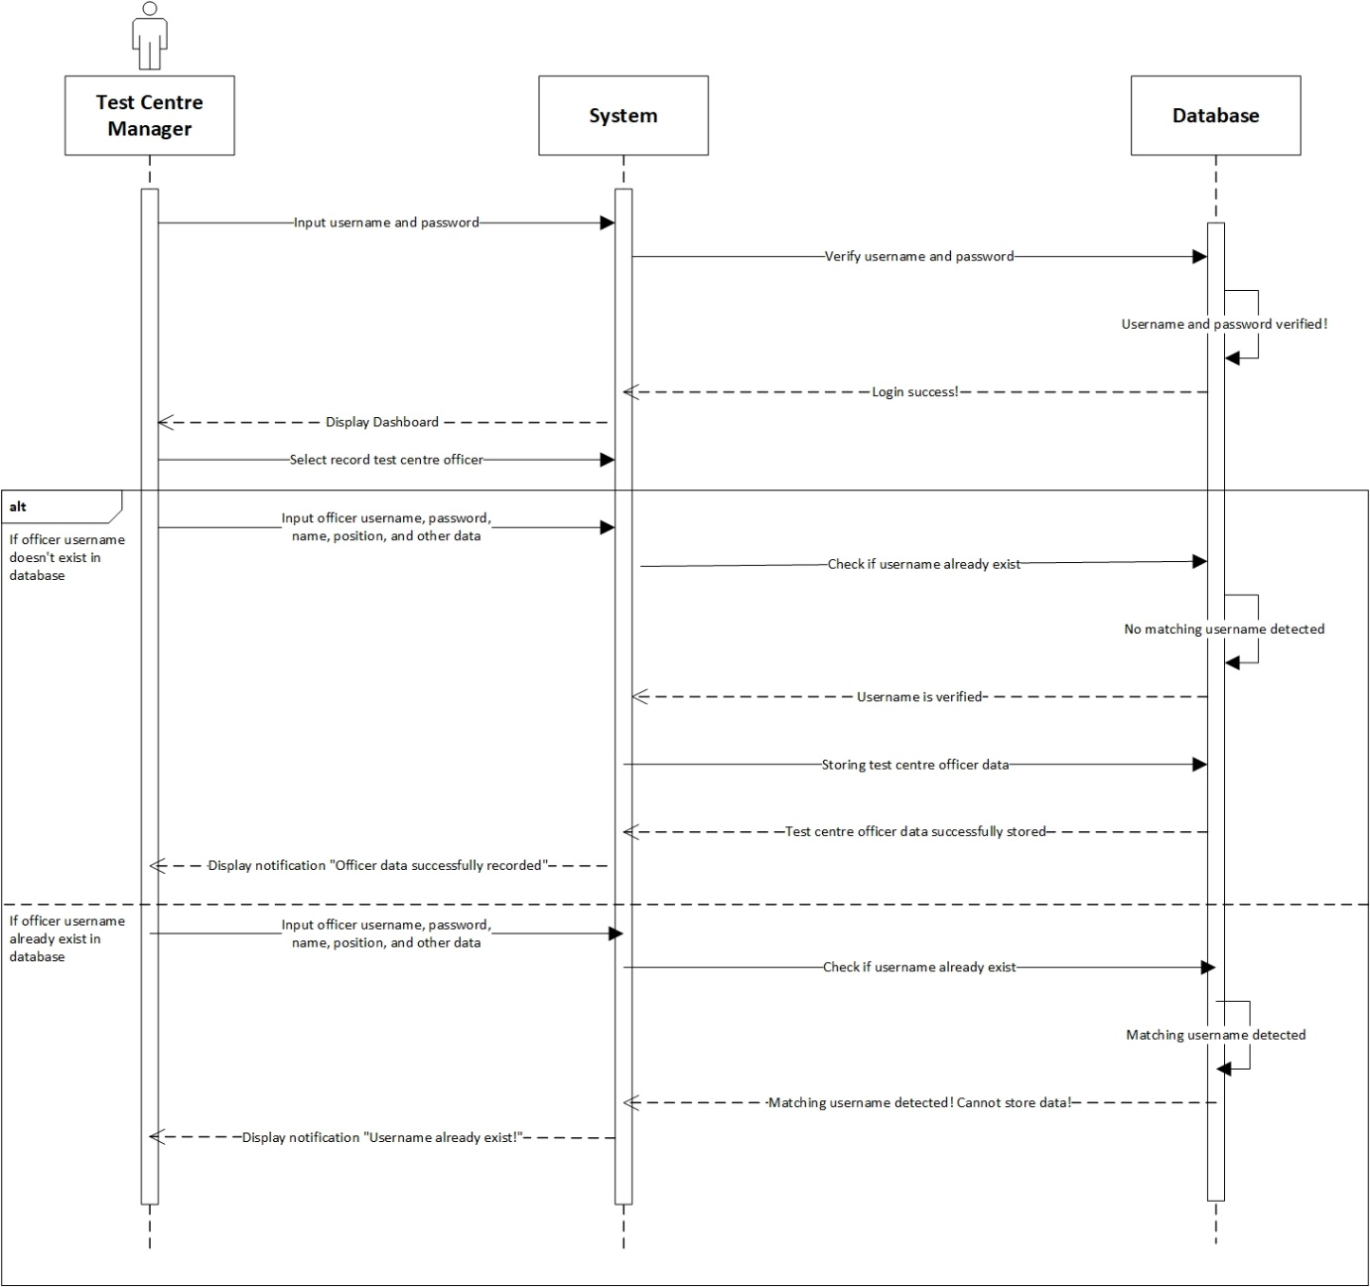

**Prepared by: I Made Siva Aditya Surya**

|  |  |
| --- | --- |
| **Cross References** | **Record Officer** |
| Operation | Login with username and password. |
| Responsible | To access the record officer menu. |
| Pre-conditions | * A valid username is required * A valid password is required |
| Post-conditions | * Username is matched * Password is matched * Display dashboard |
| **Cross References** | **Record Officer** |
| Operation | Record test centre officer with username, password, name, email, phone, gender, address, age and birth date. |
| Responsible | To be recorded in system and able to access the test centre dashboard. |
| Pre-conditions | Following data below that should be available:   * Username * Password * Name * Email * Phone * Gender * Address * Age * Birth Date |
| Post-conditions | * Username has not been existed. * Recorded in system. * Display dashboard. |
| **Cross References** | **Record Officer** |
| Operation | Record test centre officer with username, password, name, email, phone, gender, address, age and birth date. |
| Responsible | To be recorded in system and able to access the test centre dashboard. |
| Pre-conditions | Following data below that should be available:   * Username * Password * Name * Email * Phone * Gender * Address * Age * Birth Date |
| Post-conditions | * Username has been existed. * Test Centre Manager must be re-enter new username. * Display dashboard. |

1. **Record New Test**

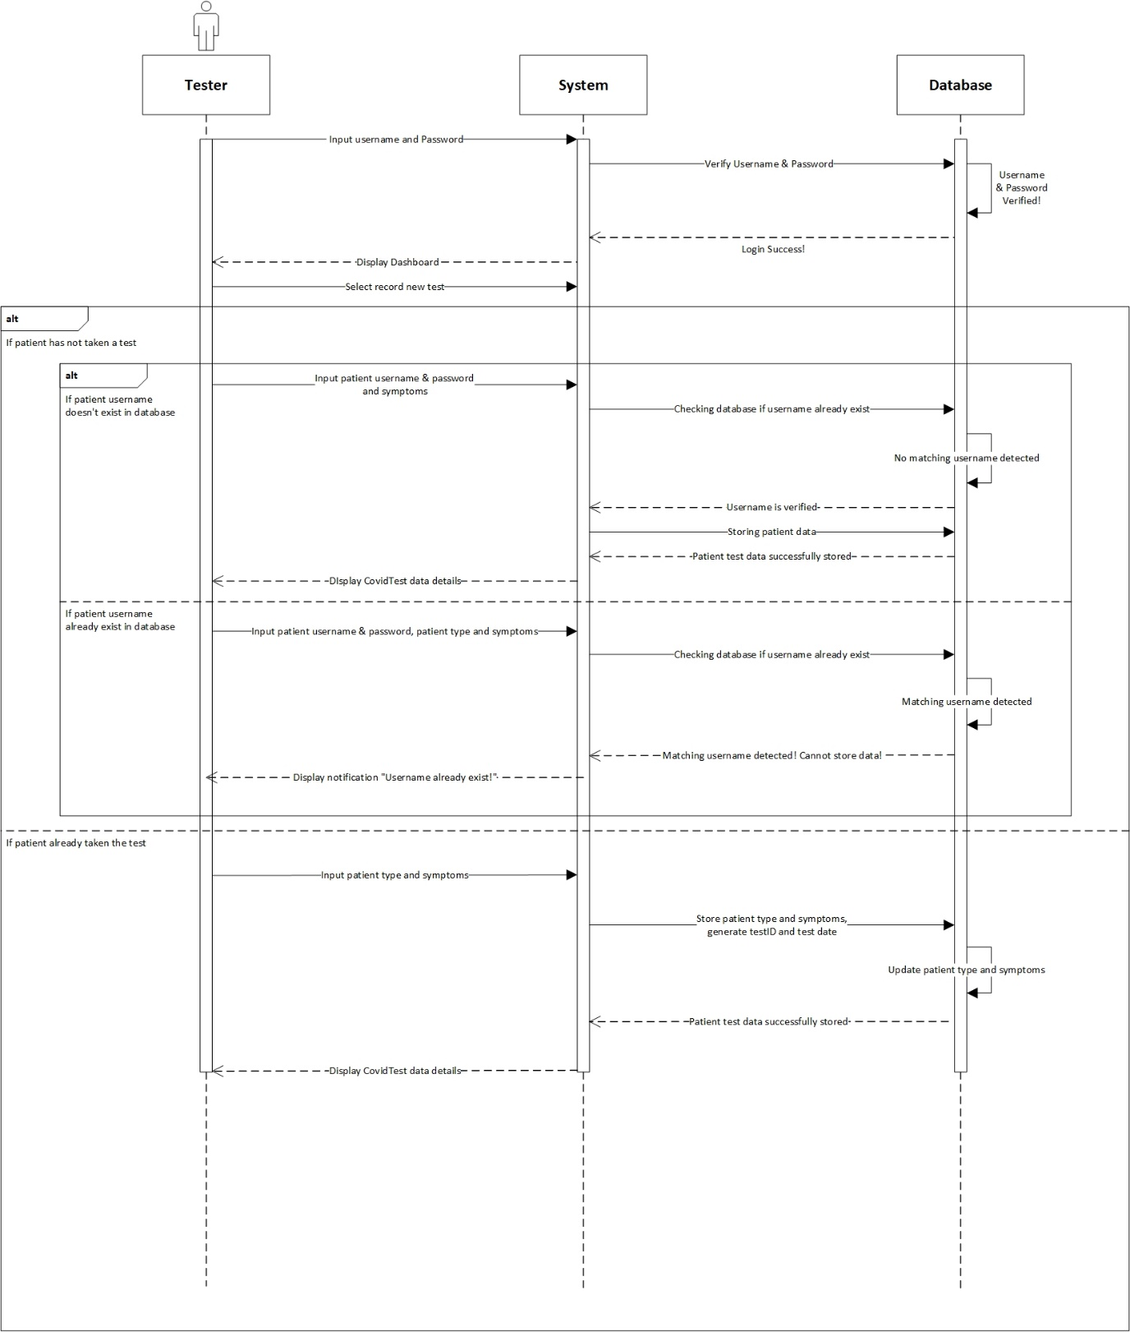

**Prepared by: I Made Siva Aditya Surya**

|  |  |
| --- | --- |
| **Cross References** | **Record New Test** |
| Operation | Login with username and password. |
| Responsible | To access the record new test menu. |
| Pre-conditions | * A valid username is required * A valid password is required |
| Post-conditions | * Username is matched * Password is matched * Display dashboard |
| **Cross References** | **Record New Test** |
| Operation | Record tester with username, password and symptoms. |
| Responsible | To be recorded in system that if patient has been not taken the test. |
| Pre-conditions | Following data below that should be available:   * Username * Password * Symptoms |
| Post-conditions | * Username, password and symptoms has not been existed. * Successfully added to system. * Display dashboard. |
| **Cross References** | **Record New Test** |
| Operation | Record tester with username, password, patient type and symptoms. |
| Responsible | To be recorded in system that if patient has been not taken the test but already register an account. |
| Pre-conditions | Following data below that should be available:   * Username * Password * Patient type * Symptoms |
| Post-conditions | * Username, password, patient type and symptoms are matched. * Display dashboard. |
| **Cross References** | **Record New Test** |
| Operation | Record tester with patient type and symptoms. |
| Responsible | To be recorded in system that if patient has been taken the test. |
| Pre-conditions | Following data below that should be available:   * Patient type * Symptoms |
| Post-conditions | The list of the patient details will be display. |

1. **Update Test Result**

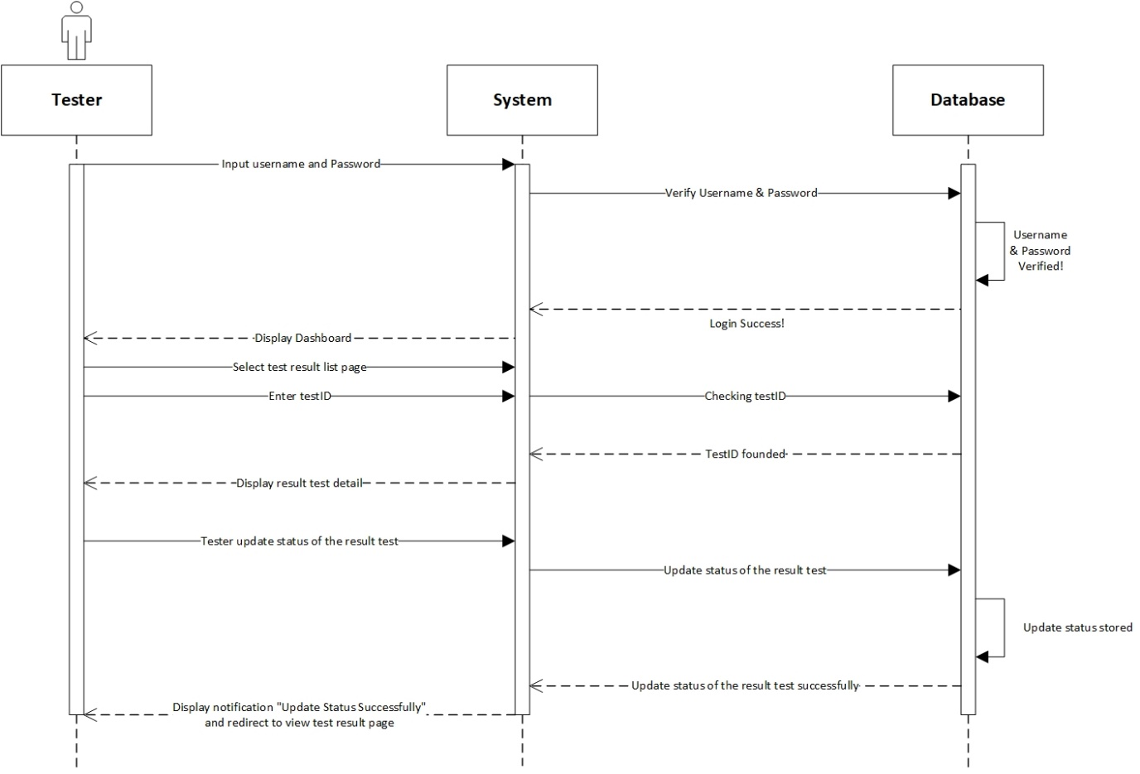

**Prepared by: I Made Siva Aditya Surya**

|  |  |
| --- | --- |
| **Cross References** | **Update Test Result** |
| Operation | Login with username and password. |
| Responsible | To access the update test result menu. |
| Pre-conditions | * A valid username is required * A valid password is required |
| Post-conditions | * Username is matched * Password is matched * Display dashboard |
| **Cross References** | **Update Test Result** |
| Operation | Update test result of the tester. |
| Responsible | To update the result test status of the tester. |
| Pre-conditions | The result test and testID must be available. |
| Post-conditions | Update result test status tester was successfully changed to the system. |

1. **Generate Test Report**

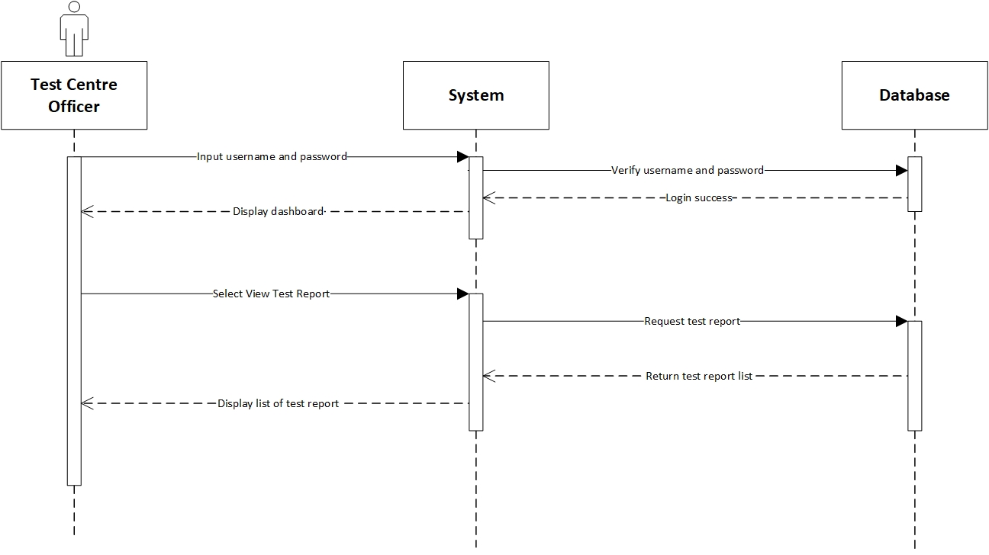

**Prepared by: I Made Siva Aditya Surya**

|  |  |
| --- | --- |
| **Cross References** | **Generate Test Report** |
| Operation | Login with username and password. |
| Responsible | To access the generate test report menu. |
| Pre-conditions | * A valid username is required * A valid password is required |
| Post-conditions | * Username is matched * Password is matched * Display dashboard |
| **Cross References** | **Generate Test Report** |
| Operation | View data test report from test centre officer menu. |
| Responsible | To view all list data test report. |
| Pre-conditions | The test centre officer object and test report must be available. |
| Post-conditions | The list of test report will be display test id, test date, result date and status. |

1. **View Testing History**

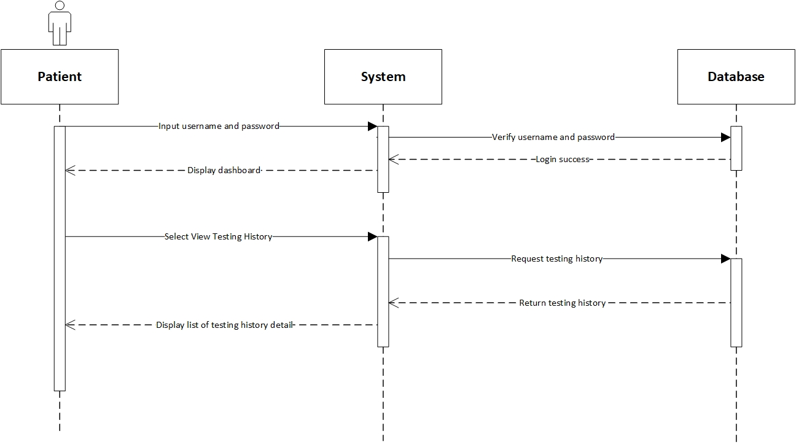

**Prepared by: I Made Siva Aditya Surya**

|  |  |
| --- | --- |
| **Cross References** | **View Testing History** |
| Operation | Login with username and password. |
| Responsible | To access the view testing history menu. |
| Pre-conditions | * A valid username is required * A valid password is required |
| Post-conditions | * Username is matched * Password is matched * Display dashboard |
| **Cross References** | **View Testing History** |
| Operation | View testing history from patient menu. |
| Responsible | To view all list data testing report. |
| Pre-conditions | The patient object and testing report must be available. |
| Post-conditions | The list of testing history will be display test id, test date, result date and status. |

1. **Logout**

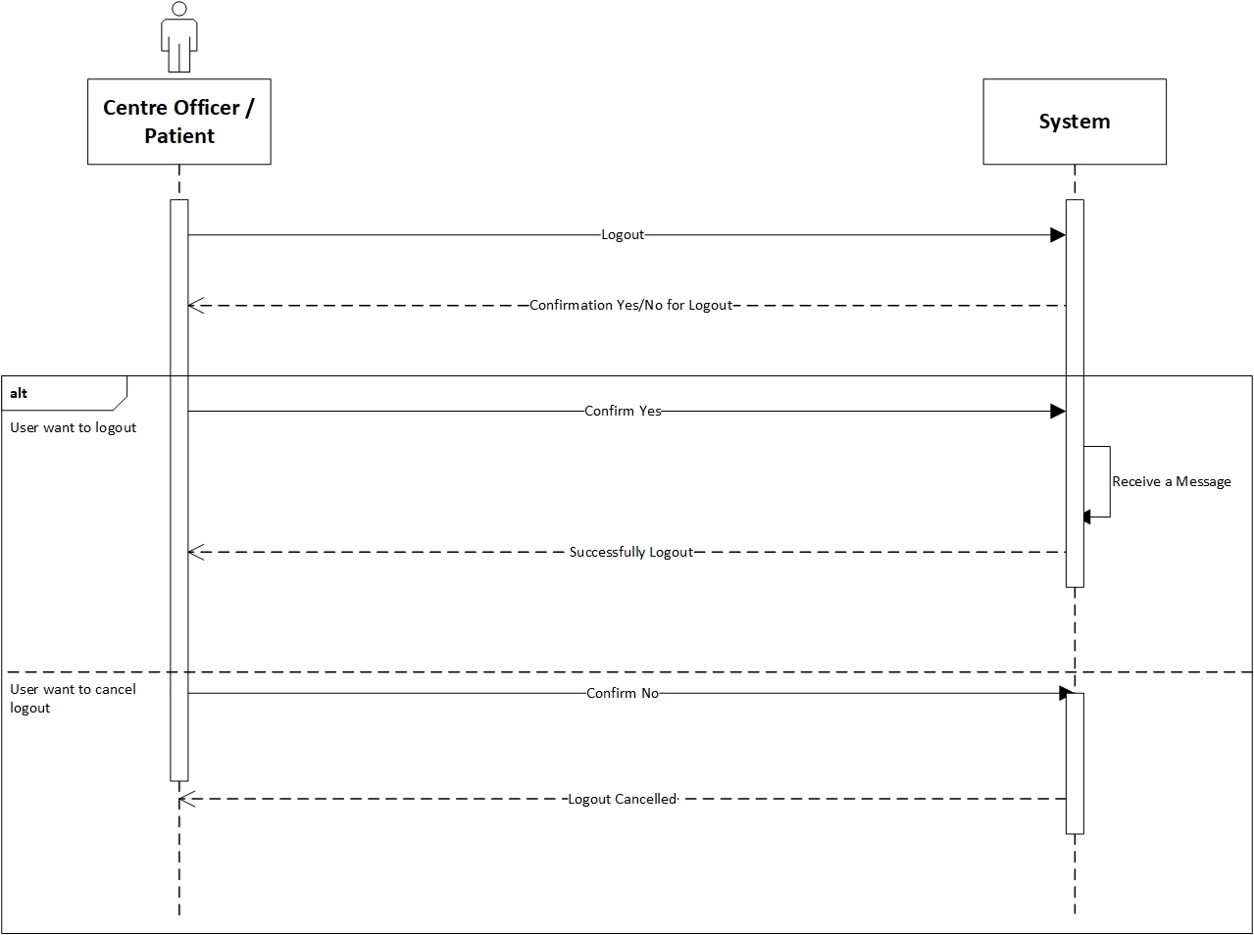

**Prepared by: Ida Bagus Gede Awidya Andika**

|  |  |
| --- | --- |
| **Cross References** | **Logout** |
| Operation | Centre officer or patient want to log out |
| Responsible | To log out or exit from the system |
| Pre-conditions | The centre officer or patient accepts if they want to log out |
| Post-conditions | Success logout from the system. |
| **Cross References** | **Logout** |
| Operation | Cancel to log out |
| Responsible | To cancel log out or exit from the system |
| Pre-conditions | The centre officer or patient want cancel the log out by clicking the “No” option in the system. |
| Post-conditions | Cancel logout from the system |